**CST-361 - Design Report Template**

|  |  |  |
| --- | --- | --- |
| **Topic:** | CLC – Project Milestone 1 | |
| **Date:** | *December 17, 2018* | |
| **Revision:** | *1.0* | |
| **Team:** | 1. *Fredrick Onduso Ondieki* | |
|  | |
|  | |
|  | |
| **Weekly Team Status Summary:** | |  |  |  |  | | --- | --- | --- | --- | | **User Story** | **Team**  **Member** | **Hours**  **Worked** | **Hours Remaining** | | Researched how I will carry out the project in terms of organization, how often I will be reviewing the application code as well as the execution. This includes the first project identification and navigation. | Fredrick Ondieki | *1.0* |  | | Researched on existing IoT applications. Agreed that I will be building an **Online Bookstore.** | Fredrick Ondieki | 1.0 |  | | The Online Bookstore will have two modules;   * Admin Portal- Books Management * Account Module- Handle the user and guest activities * Other Sections- Shopping Cart and Browsing books | Fredrick Ondieki | 2.0 |  | | Decided to use the Agile development method in designing and producing the project. This will ensure I will keep track of the project development stages per the milestones. | Fredrick Ondieki | 0.5 |  | | Created a UML draft of the IoT application that will be developed inclusive of the end user. | Fredrick Ondieki | 1.0 |  | | Drafted the UML component diagram depicting the logical block of the Online Bookstore. | Fredrick Ondieki | 1.0 |  | | Created a UML use case class diagram modeling the attributes for the Online Book Store. | Fredrick Ondieki | 1.5 |  | | Created the UML deployment diagram for the project | Fredrick Ondieki | 1.0 |  | |  |  |  |  | | |
| **GIT URL:** | https://github.com/FREDDYSMALLZ/OnlineBookStore_CST-361 | |
| **Peer Review:** | *Y/N* | Yes. I acknowledge that I have reviewed this report and agreed to the approach that I will be taking. |

**Planning Documentation**

**Agile Scrum Product Backlog:**

https://github.com/FREDDYSMALLZ/OnlineBookStore_CST-361

**Agile Scrum Sprint Backlog:**

https://github.com/FREDDYSMALLZ/OnlineBookStore_CST-361

**Agile Scrum Burn Down Chart:**

https://github.com/FREDDYSMALLZ/OnlineBookStore_CST-361

**Agile Retrospective Results:**

*The following table should be completed after each Retrospective on Things That Went Well (Keep Doing). An alternative to the following table is to use a Mind Mapping tool such as Coggle. If you use a Mind Mapping tool you must include a URL or Image File.*

|  |
| --- |
| **What Went Well** |
| I was able to successfully identify the IoT application to be developed. |
| Successfully completed the design documentation for the project. |
|  |

*The following table should be completed after each Retrospective on Things That Didn’t Go Well (Stop Doing) and What Would Be Done Differently Next Time with an Action Plan to Improve (Try Doing and Continuous Improvement). An alternative to the following table is to use a Mind Mapping tool such as Coggle. If you use a Mind Mapping tool, you must include a URL or Image File.*

|  |  |  |
| --- | --- | --- |
| **What Did Not Go Well** | **Action Plan** | **Due Date** |
| No enough data to create Agile Scrum Chart. | Enough data availability in later milestones will be able to create a Agile Scrum Burn Down Chart |  |
|  |  |  |
|  |  |  |

**Design Documentation**

This section will include the different designpattern used to develop the application. These diagrams include:

* UML Use case diagram
* UML Class diagram
* UML Component diagram
* UML Deployment diagram

**Class Diagrams:**

The class diagram bellow shows all the potential features of the application.



**Use Case diagram**

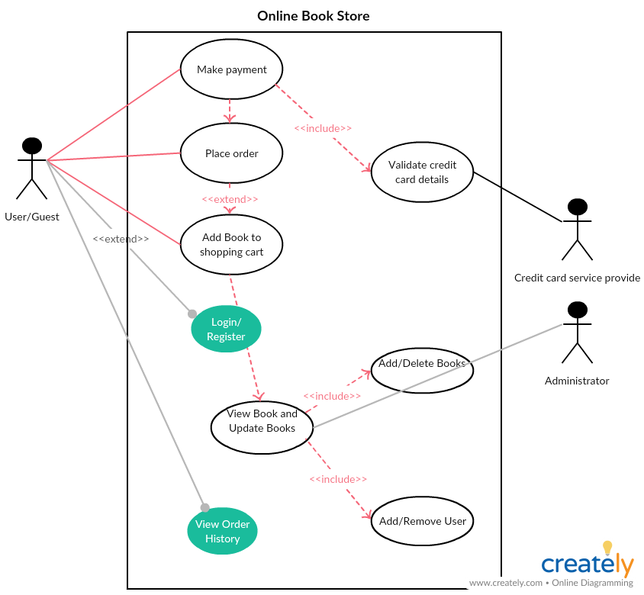

**Component diagram**

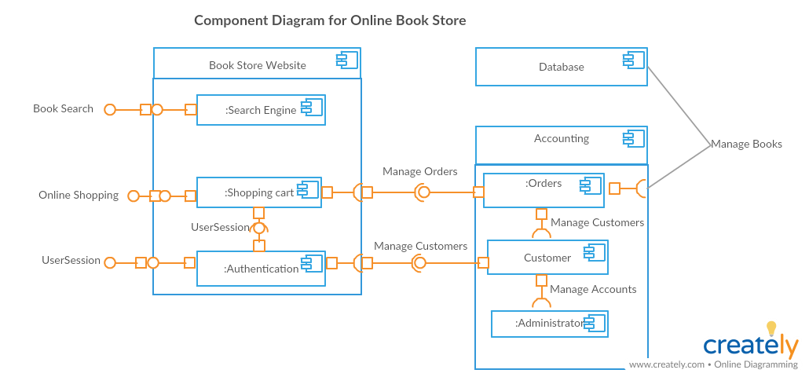

**Deployment Diagram**

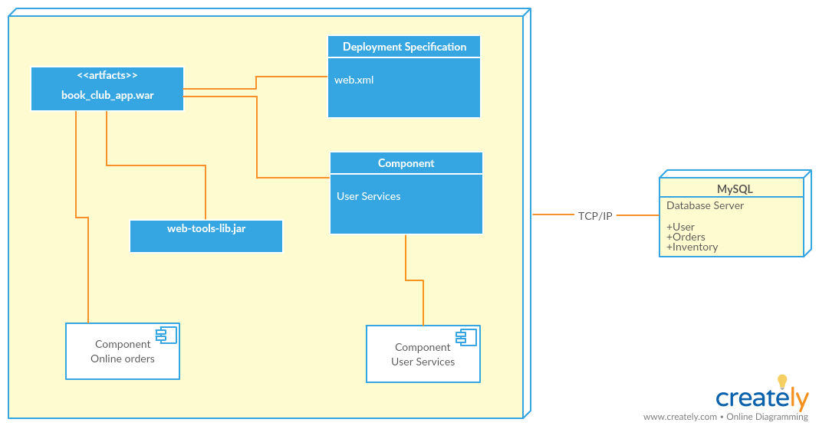

**Service API Design:**

This project intends to use the MySQL as a relational database, among other services APIs which will be included in later milestones.

**Security Design:**

This report outlines the security design that will be used in the store. First, the user will be required to register for account. Afterwards, the user name and password used will be used to authenticate and authorize the user to receive services from the online book store application. On the other hand, the administrator has all the privileges in controlling the application functionalities. One of the administrator roles is not limited to adding and removing users but also perform all CRUD functions for the books.

**Other Documentation:**